Task 1:
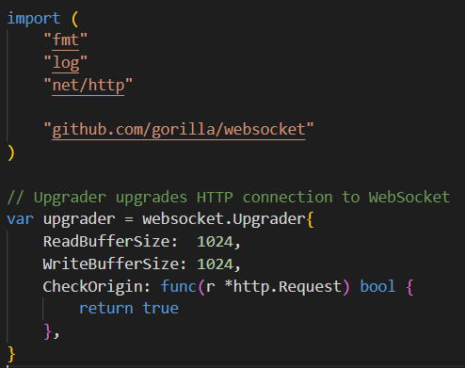
- Importing the Gorilla WebSocket package.
- upgrader upgrades HTTP connection to WebSocket (ReadBufferSize and WriteBufferSize are size buffer for reading/writing data, CheckOrigin true to allow all connection).
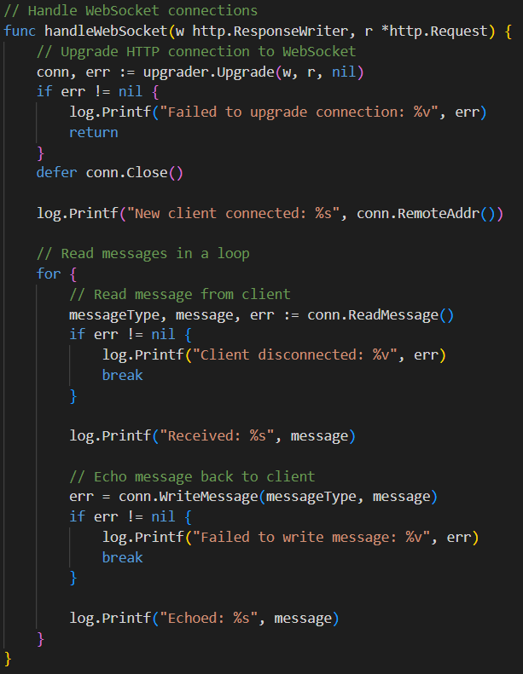
- w http.ResponseWriter: lets the server send a response to the client
- r *http.Request: contains the content of HTTP request from the client.
- upgrader.Upgrade converts the HTTP connection to WebSocket.
- Then read messages from client in a loop. If the client disconnects, the loop breaks.
- Echo messages back to sender.
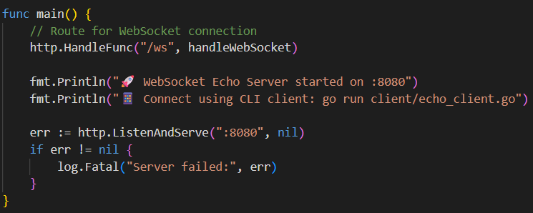
- http.HandleFunc("/ws", handleWebSocket): registers /ws endpoint to handle WebSocket connections.
- http.ListenAndServe(":8080", nil): starts the HTTP server on port 8080
- log.Fatal logs any startup error and exits.
Output:
Server:
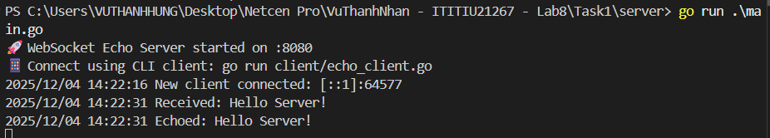
Client:
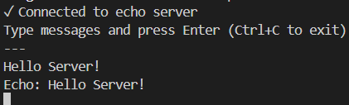

Task 2:

Output:
Server:
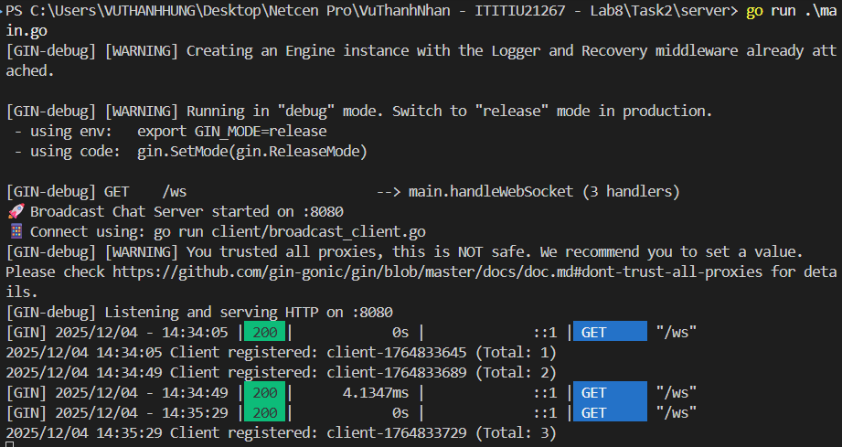
Client 1:
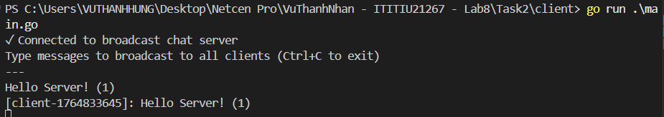
Client 2:
